Work Schedule

Various elements combine to form a complete work schedule. You can process work schedule elements that provide flexibility while you define and set the time relevant data as per business requirements. With work time elements, you can react to the changes in internal and external work time provisions, with less expenditure on time and cost.

You just need to make the changes to the applicable elements as per new time provision and it allows you to make the changes in work time in the work time schedule automatically.

Let us learn about the Work Schedule elements.

Daily Work Schedules

This contains the work and break times in a particular day. It is the smallest unit of work schedule.

**Work time model** − It consists of a combination of the working and non-working days. Example – Mon-Friday are working days and Sat-Sun are non-working days. This work time model can repeat itself for a certain period of time.

You can generate work schedules by applying work schedule rule to a calendar. Working times for an employee group and for individual employees are defined as per work schedules.

A period work schedule is assigned to an employee in a work schedule rule. Personal work schedule is also defined for each employee while including individual time data in work schedule for several employees in Infotypes 2001 Absences, 2002 Attendances, etc.

Work Schedule Rules

Work Schedule rules are used to define the period when work schedule is to be used and the day of the period when work schedule is to be generated. Common work schedule rules are early or late shift timing, flexible working time and flextime.

To define employee subgroup groupings −

**Step 1** − Go to SPRO → IMG → Time Management → Work Schedules → Work Schedule rule and work schedules → Define employee subgroup grouping.

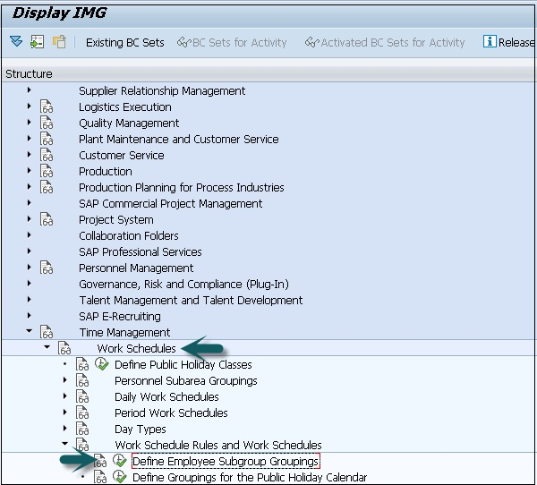

**Step 2** − Select Define Employee subgroup grouping.

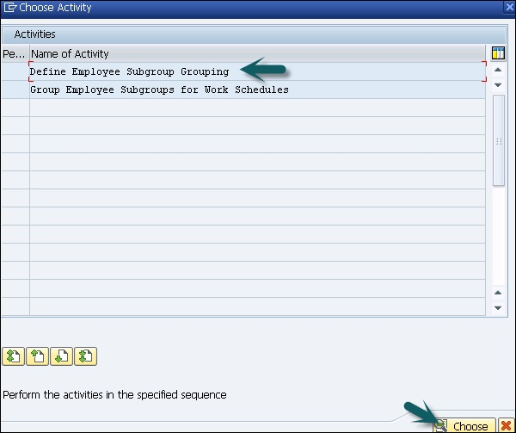

**Step 3** − Click the New Entries tab.

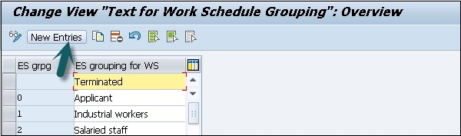

**Step 4** − Enter the fields as given below.

**ES grpg** − One digit key that identifies employee subgroup grouping.

**ES group for WS** − Update the text of the employee subgroup and click the save icon.

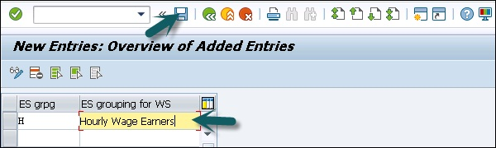

**Step 5** − Go back to SPRO → IMG → Time Management → Work Schedules → Work Schedule rule and work schedules → Define employee subgroup grouping.

Select Group Employee subgroups for work schedules.

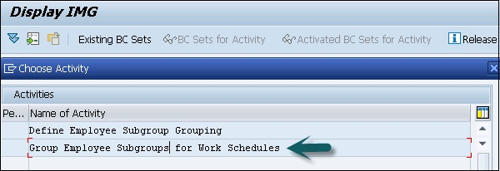

**Step 6** − Enter country grouping key and press ENTER.

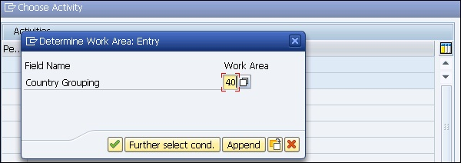

**Step 7** − Enter ES grouping and click the Save icon at the top.

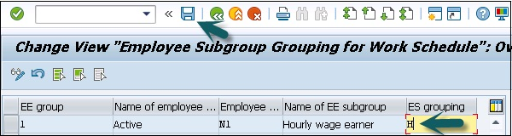

Data Saved

**Step 8** − The next step is to set the work schedule rules and work schedules −

Go to SPRO → IMG → Time Management → Work Schedules → Work Schedule rules and work schedules → Set Work schedule rules and work schedule.

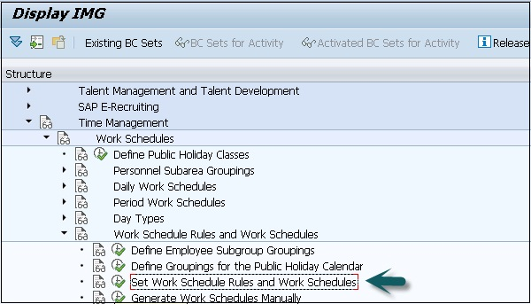

**Step 9** − Select defined **work schedule rule** and click **Copy As** −

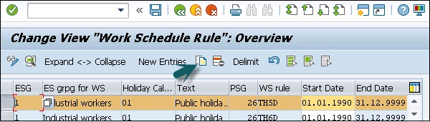

**Step 10** − Enter the ES grouping key and other details as per your organization requirement. Click the Save icon to save the configuration.

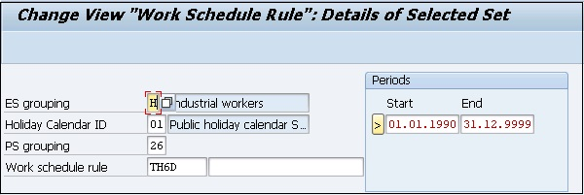

To generate work schedule in batch

**Step 1** − Go to SPRO → IMG → Time Management → Work Schedules → Work Schedule rule and work schedules → work schedule in batch.

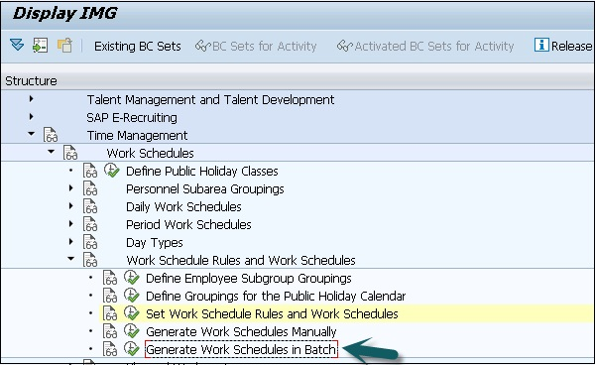

**Step 2** − Enter ESG calendar and Holiday Calendar ID and click Execute.

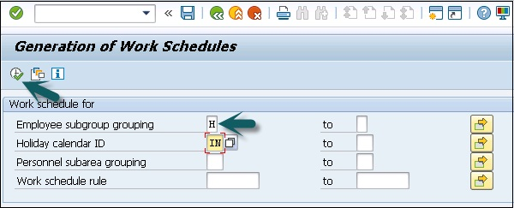

Work schedule is generated.

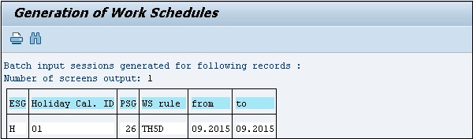

SAP HR - Public Holiday Calendar

Public Holiday Calendar contains a collection of public holidays, which are valid for a location - Personnel Area and Personnel Subarea. You can say that a company having office in Chennai and Hyderabad will have two different public holiday calendars.

Therefore, it means that a public holiday’s calendar that is valid for Chennai employees will not be applicable for Hyderabad employees.

Follow the steps given below −

**Step 1** − Transaction code to access Public Holiday Calendar: SCAL.

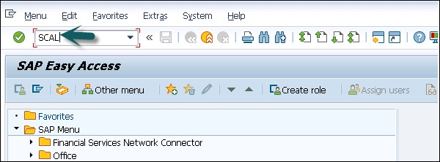

**Step 2** − When you execute this transaction code, you see the following screen −

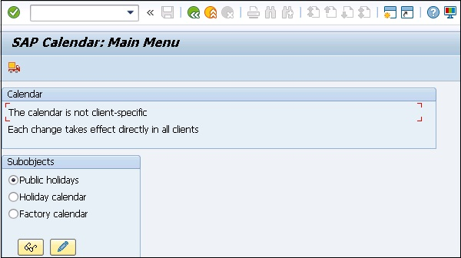

**Step 3** − We first create a list of public holidays for a country and then assign these holidays to different locations. For example, one holiday - Republic day is valid for both Chennai and Hyderabad. You have to create one public holiday and assign it to the public holiday calendar for both the locations.

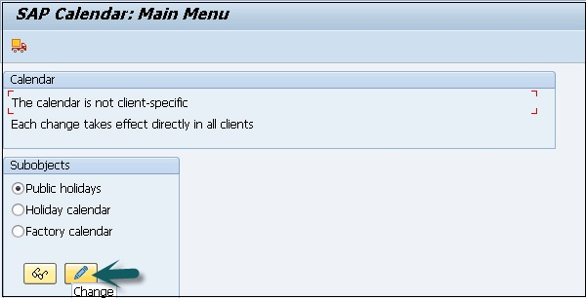

You will see the screen as shown below −

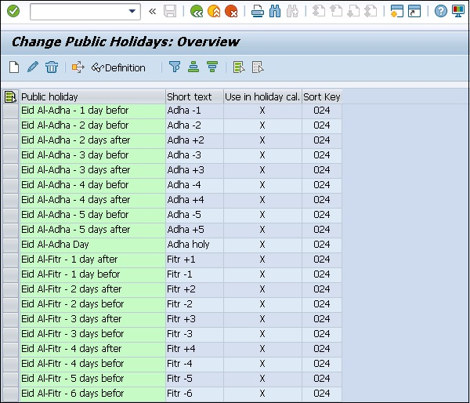

Description of various fields −

* **Public Holiday** − This field displays the long text of the Public Holiday.
* **Short Text** − This field displays the short text of the Public Holiday.
* **Use in Holiday Cal** − This field helps us to check if a public holiday is being used in a public holiday calendar or not. It is not possible to edit a public holiday when it is being used in a public holiday calendar. To edit a calendar, you have to remove it from all the public holiday calendars where it is used and then make the necessary changes and again re-assign the public holiday to the relevant public holiday calendars.
* **Sort Key** − This field helps to group together all the public holidays valid for a country. Sort key is a three-character key. It is recommended that its naming convention should be in the “Znn” format, where “nn” defines the country grouping. For example, the sort keys for public holidays for Australia and India are Australia-Z13 and India-Z40 respectively.

**Attendance**

SAP HR systems can maintain attendance and absence.

To maintain attendance and absence in SAP HR system, go to SPRO → IMG → Time Management → Time data recording and administration → Absence.

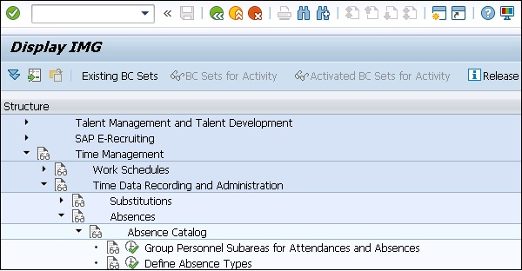

* To view attendance quotas and absence quotas of your employee, you can use this query −

**Query** − 0HCM_PT_T01_Q0001

* With quota entitlement, this also includes compensated, deducted and unused quotas.
* To obtain details about an employee’s attendances and absences, you can use query −

**Query** − 0HCM_PT_T01_Q0002

This query is called from manager self-service from attendance and absence quota overview query and the results display the information for the employee that you selected in a query.

Shift Management in HR

Shift management deals with accurately defining the number and the type of resources that are required to run the business operations.

Shift planning is one of the components of Personnel time management. Exchange of data between human resources and personnel management components ensures the data given below −

* Changes relevant to planning in time data recording
* Changes relevant to payroll in shift planning
* Changes relevant to planning in time evaluation
* Integration with HR components

|  |  |
| --- | --- |
| **Function Required** | **Component Required** |
| Access to organizational structures | Organizational Management (PA) |
| Access to employee qualifications | Qualifications/Requirements (PA-PD-QR) |
| Determining an employee’s working times | Time Data Recording and Administration (PT-RC) |
| Simulated evaluation of employee working hours during planning process | Time Evaluation (PT-EV) |
| Running the payroll for an employee | Payroll (PY) |

Shift Planning Component

To start the shift planning component follow the steps given below −

**Step 1** − Human Resource → Time Management → Shift Planning → Change Shift Plan.

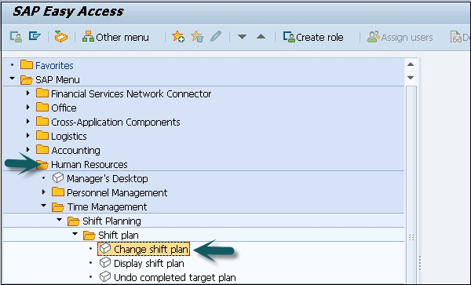

**Step 2** − Select the Shift Planning profile and Organizational Unit as shown in the screen shot given below and click Change.

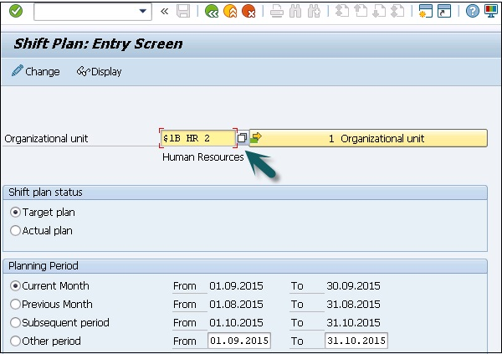

**Step 3** − You can select the shift plan. In the Shift plan status field, select the ID of the desired shift plan (either target or actual plan).

In the Planning period section of the screen, select the time period for which you want to plan the shifts.

Change Shift Plans

There are two types of Shift plans namely, target and actual plans.

* You can use Shift plans to display the employees who are selected from the evaluation path of the entry profile and the entry objects.
* The calendar for the desired planning period can be checked and it can be used to view additional information like organizational unit, personnel number, etc. for a selected employee in a separate information column.
* Note that it is possible to change the target plans at any time till a target plan is complete. You can only edit the actual plan once you have completed the target plan. You can change actual plans at any time.
* To change a target plan if it is not completed, you need to set target plan complete or partially deleted.

Important T-codes for Time management

* PP61: Change Shift Planning
* PP63: Change Requirements
* PP62: Display Requirements
* PO17: Maintain Requirements Profile
* PP69: Choose Text for Organizational Unit
* PP6B: Attendance List
* PP6A: Personal Shift Plan
* PP72: Shift Planning
* PQ17: Actions for Requirement Profiles
* PP67: Create Requirements
* PP60: Display Shift Planning
* PP64: Choose Plan Version
* PP65: Edit Entry Object
* PP66: Shift Planning: Entry Profile

Overtime and Breaks Schedules

Overtime and Breaks Schedules come under positive and negative time recording. There are four types of break schedules −

* Fixed Break Schedule
* Variable Break Schedule
* Dynamic Break Schedule
* Overtime Break Schedule

Fixed Break Schedule

Fixed break schedule, the timings of the break for an employee is fixed. He is provided with certain time duration. At the same time, every day, say 30 min, 60 min and only in this time-frame, an employee has to take a break.

**Example** − Break timings are fixed, i.e. 1:30 PM to 2:30 PM and an employee has to take a break daily during this time interval.

Variable Break Schedule

In this break schedule, the timing of break is not fixed. Employee is provided with a time duration. The employee can take a break within this duration only.

**Example** − Break duration - 12:30 PM to 2:30 PM. An employee can take any one hour as break and if the break time exceeds the fixed break time, the salary is reduced.

Dynamic Break Schedule

In Dynamic break schedule, no certain time range is given and break can be taken after working for a certain number of hours.

**Example** − An Employee can take a break after working continuously for 4 hours from the start of the shift. In this case, if an employee’s shift starts at 9:00 AM, he can take the break at 1:00 PM.

Overtime Break Schedule

In overtime break schedule, you define the break time, which is taken during over-time of the shift. This can be a fixed break schedule, which is taken during over-time.

**Example** −

* **09:00 AM to 05:00 PM** − Routine working Hours.
* **05:00 PM to 9:00 PM** − Overtime Hours.
* **7:30 PM to 08:00 PM** − Overtime Break.

Following are the T-Codes that can be used to manage work schedule −

* T-Code to Generate the Work Schedule PT01.
* T-Code to Change the Work Schedule PT02.
* T-Code to Display the Work Schedule PT03.